

Scargill Church of England Primary School

Behaviour Policy

Introduction
The establishment and maintenance of high standards of behaviour are essential for the happiness and health of each individual, the school and the wider community. As an Attachment and Relationship Aware school, we understand that behaviour has a meaning and is a form of communication. Good behaviour is not automatically learned but needs to be taught, like any other curriculum area and supported by parents. We also recognise that behaviour mistakes are learning opportunities.
This policy outlines the expectations we have at Scargill Church of England Primary School regarding behaviour, and our approach to supporting children’s behaviour development. Our expectations and actions are based on our mission statement and stem from the STARFISH values below.
Sportsmanship
Tolerance
Appreciation
Respect
Friendship
Inspiration
Sensitivity
Honesty & Helpfulness

Each of these values is reinforced through the teachings in the Bible as follows:
Sportsmanship
Put yourself aside, and help others get ahead. Don’t be obsessed with getting your own advantage. Forget yourselves long enough to lend a helping hand. Philippians 2: 3-4
Tolerance
Make every effort to live in peace with everyone and to be holy. Hebrews 12:14
Appreciation
Give thanks in all circumstances; for this is God’s will for you in Christ Jesus. Thessalonians 5:18
Respect
Do to others as you would have them do to you. Luke 6:31
Friendship
Therefore encourage one another and build each other up, just as in fact you are doing. Thessalonians 5:11
Inspiration
We have different gifts, according to the grace given to each of us, let us use them. Romans 12:6
Sensitivity
My dear brothers and sisters, take note of this: everyone should be quick to listen, slow to speak and slow to become angry. James 1:19
Honesty
A good person is guided by his honesty; the evil person is destroyed by his dishonesty. Proverbs 11:3
Helpfulness
For I was hungry and you gave me food, I was thirsty and you gave me drink, I was a stranger and you welcomed me. Matthew 25:35

All adults working in our school have a responsibility for the day–to-day management of the behaviour of the children, under the overall guidance of the Head of School.
Parents play a vital role in supporting the school’s approach by encouraging positive behavioural patterns in their own children. Parents are encouraged to sign and abide by the Home-School Agreement annually.
The Governors are responsible for reviewing this policy and supporting the Head of School and staff in its implementation. They should also alert the Head of School if they have concerns regarding any aspect of its implementation.
The children are expected to develop an increasing responsibility for their own behaviour and in helping to modify the behaviour of others. They will be encouraged to accept varying degrees of responsibility, both in and out of the classroom with the purpose of promoting independence, self-reliance and trustworthiness. They are involved in agreeing with the rules and informing us of any areas for development. The School Council is a mechanism for this liaison.
Positive Behaviour Management
All pupils are expected to adhere to and abide by the STARFISH values as detailed above.
They are also expected to obey school rules which are there to ensure safety and efficiency during the school day.
Although it is necessary for staff to use sanctions from time to time the emphasis is on praise, positive relationships and rewards for expected behaviour, and as such staff will use a positive, patient and supportive approach, working proactively wherever possible.
By focusing on and highlighting the positive rather than drawing attention to undesirable behaviours, staff establish social norms and thus embed the intended culture. When children do not meet an expectation, staff should supportively re-set the expectation.
Our aims are to help children to experience the benefits that come from being an active partner in a well-ordered community and to help them gain the self-discipline and self-regulation, which are prerequisites for a happy and successful adult life.
Physical Intervention
It may be necessary on occasions to use reasonable force to protect children. We have a Physical Intervention Policy, which outlines when and how this may be appropriate.
Day to Day procedures
- Children are to walk around the school sensibly & quietly, keeping to the left when necessary.
- The gates are open at 8.45 am. Children should not arrive at school before 8.45 am. Children can enter school when they arrive.
- No children may stay in classrooms, at playtimes, lunchtimes or at the beginning or end of the school day, unless they have been given permission by a teacher.
Out of bounds areas:
- The wildlife area by the side of the playground unless supervised.
- The front of school.
- All car parking areas.
- Behind the equipment storage sheds.
- Safety bars near fire exits.
- The railings should not be climbed on.
During lunchtime children have mid-day supervisors designated to particular areas & days who report to teachers where appropriate.
In summertime, when the field is in use, football and other ball games are allowed on the field.
- No over aggressive games including large numbers of children (i.e. Bulldog) are allowed.
- No fighting, either pretend or real.
- In winter snowballing and sliding are not allowed.
- Toys and games are not allowed in school. The only exception to this would be an “end of term” games afternoon, where teachers request games for a specific occasion.
- Children should use the toilets on their way out to play, or by asking the duty teacher’s permission to re-enter the building during playtime.
- Children should be prepared to open doors for approaching adults and for each other

Class and School Rules
Each class operates a Good to be Green system for low level disruptive behaviour.
The school has the same set of 3 rules for everyone. These were agreed by the children and staff working together.
These are:-
- Follow instructions with thought and care.
- Care for everyone and everything.
- Show good manners at all times.
The rules are clearly displayed in each class and throughout the school and used by all staff.
Rewards we use
It is important that staff know the children really well in order to effectively reward them. Some children prefer quiet praise, whilst others can be rewarded in front of peers/ whole school. For some children a reward may trigger an uncontrollable emotional and physical reaction, and therefore this also needs to be considered when deciding when and how a reward should be given. Praise has a reinforcing and motivational role.
Positive behaviour in school may be rewarded with any of the following:
Positive comments both spoken and written
Stickers
Starfish values rewards (See Appendix A)
Stamps
Dojo points
Dojos home to parents
Freedom points for whole class achievements
Scargill Star Assemblies
Stevens Award
Star of the day/week

Dojo points: Once awarded a Dojo point can never be deducted. They are intended to help staff focus on positive rather than negative behaviour e.g. if a child is continuing to stay on task when a partner is trying to distract him, staff may choose to reward the child on task rather than apply a sanction to the child who is not.

Unacceptable Behaviour

Where a child displays unacceptable behaviour it is important that age, SEND and emotional state are factored into how staff respond. Consequences are an important part in supporting a child to learn from their actions, but must be given in a respectful manner.

Examples of unacceptable behaviour are; hitting, kicking, spitting, swearing, rudeness to an adult, refusal to follow instructions and bullying.
Unacceptable behaviour will be dealt with by the following procedure:

Card System
Time negative behaviour is seen | Action | Consequence  (a reflection block is 15 minutes) | Examples
1st | Verbal warning |  | Talking when asked not to, being silly in lessons, not doing what has been asked, breaking a school rule, disrupting the learning of others. Poor behaviour at lunchtimes – specific examples in appendix B
2nd | Green card turned over to white
3rd | White card is turned to yellow | 1 block of reflection time
4th | Yellow card is turned to red and parents are informed | 2 blocks of reflection time |  |  | Examples of how a straight red card can be issued are; for continued refusal to follow adult instruction, disrespectful behaviour, verbal insult fighting, Swearing.
5th | Incident log, parents informed. Moved onto Report system |  |  |  | Straight to the report system for, physical assault, threat of assault, leaving class without permission; discriminatory behaviour including, for example, homophobic, transphobic and racist language; confirmed bullying; mobile phone use in school or receiving 3 red cards in one week.
Report system
1st incident log | Child is placed on report for 1 week | - Child will miss an entire day’s privileges  - A report card will be issued to monitor behaviour each lesson
2nd incident log | Child is placed on report for 2 weeks | - Child will miss 2 days privileges  - A report card will continue to be used to monitor behaviour each lesson
3rd incident log |  | Child is moved onto the contract system  Child can be moved directly to the contract system if an incident is deemed by the SLT to be serious enough.
Contract system
- Child will be placed on a Stay in School Contract  - Child will be recorded as ‘At risk of exclusion’ |  | - Parent, child, a member of SLT and a governor will meet to discuss the targets which must be met for the child to stay in school and the support the school will provide to help the child.  - This will be reviewed weekly  - Child will continue with a report card  - Child may not be able to take part in extra-curricular activities, school treats or trips.  - External support may be sought |  | If targets on the contract are not met by the time of a review, the SLT will consider the following options;  - Remain on contract  - Exclusion from playtimes for a number of days  - Exclusion from lunchtimes for a number of days  - Internal seclusion for a number of days  - Exclusion from school for a number of days  - Permanent Exclusion from School.

- Staff should model a positive, patient and supportive approach through restorative reflection time which allows the child to reflect on their behaviour.
- All cards will be turned back to green at the end of each day- some sanctions from one day may need to be issued the following day.
- The child can return to the card system from the report system if they improve their behaviour to the satisfaction of the SLT.
- The child can return to the Report system from the contract system if they meet the targets set.
- All efforts will be made to avoid an exclusion including the option of an internal seclusion and consultations with outside agencies such as behaviour support.
- All children will begin each half term with a fresh start with the ‘count’ of incidents returning to zero.
- Children on the contract system at the end of a half term, may need to continue on contract until their targets are met.
- Children who are on reflection time who need physical movement to meet their needs, will have this factored into their timetable/ reflection time.
School Visits
School visits are an important part of school life and offer valuable experiences to all children, however it is important that the behaviour of children on such visits is of the highest standard. If a child’s behaviour has shown cause for concern and they have either received red cards or been subject to the report system or the contract system, it may be necessary to consider if the child should take part in a school visit.
When considering if a child may take part in a school visit, the SLT will consider all the risks associated with the child taking part in the visit and whether these can reasonably be reduced. If it is felt there may be a risk to the health and safety of any of the children and/or adults on the visit, the child may be withdrawn from participation.

Bullying
Our aim is to eradicate bullying behaviour.
We also aim to ensure that bullying incidents are noticed and that when they occur steps are taken to help both victim and bully.
We have a separate policy for anti bullying.
Staff approach to dealing with unacceptable behaviour
It is essential that staff have checked the accuracy of reported incidents. This should involve seeking the viewpoints of as many children or adults as possible. Decisions on issuing sanctions should always be made when staff are sure of the facts. Staff should discuss how the children could manage to deal with such an incident in a better way next time. Any victim and/or their parents, should always be assured that issue has been dealt with.
Roles and Responsibilities
The class teacher has responsibility for:
- Following our agreed procedures
- Creating a positive classroom environment and promoting school values
- Dealing with disciplinary issues
- Supporting the Mid-day Supervisors
- Informing the Head of School, recording incidents on Integris.
- Recording all incidents on report cards.
- Contacting parents and maintaining contact until behaviour improves.
All staff support celebration assemblies and share success.
Each member of the Senior Leadership Team is available to support the Mid-day Supervisors.
Mid-day Supervisors keep in contact with class teachers and the Head of School over dinner time difficulties. They are responsible for carrying out our agreed procedures.
The Head of School is responsible for:
- Maintaining school ethos
- Dealing with serious breaches of discipline
- Informing governors
- Exclusions
Monitoring, Evaluation and Assessment
The school will review this policy regularly, and assess its implementation and effectiveness. The policy will be implemented throughout the school by all staff.
To be reviewed July 2023.
Signed by:
 | Head of School | Date:
 | Chair of governors | Date:

Appendix A
Reward choice options for achieving Bronze, Silver or Gold STARFISH award
- Non-uniform day
- 30 mins lap-top time
- Pick the class Thrive activity
- 30 mins indoor activity eg game/library time/sensory activity
- An extra playtime

Appendix B
Scargill Playground Guidelines
1 | Follow instructions with thought and care
2 | Care for everyone and everything
3 | Show good manners at all times
 | Guiding principles are that equipment is to be used: safely, sensibly, fairly & must put away where they came from when finished.
1 | Football is to only be played on the field – no kicking of balls on playground (Summer rota)
2 | The play equipment is shared
3 | No playing or walking down the bank (including not sitting on the mosaic)
4 | No playing or hanging around the steps or railings
5 | When on just the playground not allowed past the blue cones next to the pre-school
6 | The wall next to the Y2 classroom can be used for bouncing basketballs off
7 | No kicking, throwing, grating apples
8 | No saving space when lining up for lunch. If a dispute both pupils to the back of the line.
9 | No hanging / leaning on the basketball protectors
10 | Not allowed to bring toys / reading book out at lunchtime – if a pupil does ask them to return it to their classroom / bag.
11 | Pupils are allowed paper and pencils.
12 | Not allowed in the wooded area next to the playground (due to not being able to see them)
13 | Not allowed behind the shed (due to not being able to see them)
14 | Not allowed on patio area outside Y6 classroom (due to not being able to see them)
15 | No Tug of war
16 | Tennis rackets are for playing tennis if a pupil is using them incorrectly eg as skates or sliding on them (this is not showing care for the equipment and not using it sensibly)
17 | No throwing snow balls, sliding on ice (during winter months as these activities could be unsafe)
18 | Pupils are allowed to build snowmen (assuming they do it following the guiding principles)
19 | MDS to support the implementation of the bell system at the end of lunchtime Bell 1 - stand still and listen; 2- put equipment away and 3 - line up sensibly and silently.
20 | If a MDS has told a pupil to turn their card, this needs to be communicated to the teacher straight after lunchtime has finished while the pupils are lining up to go back to class – Make a note of who, year group, what happened.
21 | No throwing grass
22 | No taking food out of the lunch hall
23 | Pupils must ask to go to the toilet
23 | No snapping in football
24 | No footsliding down the grass slope or the concrete slope

Additional appendices:
GOOD PRACTICE

At Scargill Church of England School we recognise the importance of a consistent professional response to all pupil behaviours:

• Encourage professional language as opposed to emotional
• Let children know we are trying to understand
• Create opportunities to scaffold / model more appropriate behaviour
• Promote verbal communication
• Provide pupils with a vocabulary to describe feelings
• Support adults faced with continuing stressful and frustrating situations
• Enable pupils to make “an informed choice”
• Emphasise the positive behaviours desired.

The quality of teaching and the organisation of the physical environment have a considerable effect on children’s behaviour.

Always:

1. Consider your classroom environment.

2. Provide an ordered environment in which everything has a place. Children should know where materials/equipment are and how to treat them with respect.

3. Make sure the children know what they are doing and that their work is matched to their ability.

4. Be aware of what is going on around you.

5. Do not be static.

Remember that problems are normal when children are learning and testing the boundaries of acceptable behaviour. Remember to:

• Set high standards
• Apply rules firmly and fairly
• Smile and relate
• Avoid confrontation
• Listen
• Stay calm
• Use humour, but not sarcasm
• Know the children as individuals
• Look out for positive behaviour
• Praise quickly and consistently
• Praise the behaviour rather than the child.

We do have a choice in how we behave, we can either give pupils a negative experience by using sarcasm, ridicule and humiliation which tends to destroy their self-esteem. Or, we can give them a positive experience which will build their self- esteem.

Never:
• Humiliate - it breeds resentment
• Over react - the problem will grow
• Use blanket punishment - the innocent will resent you
• Over punish - never punish what you cannot prove

Article 21: CHILDREN’S RIGHTS

• To be looked after by caring adults
• To be taught well
• To be able to rely on an atmosphere conducive to learning
• To be made to feel welcome
• Not to be talked down to
• To feel as important as anyone else
• Not to be smacked or shaken
• Not to be bullied
• Not to hear swear words

A restorative approach to resolving conflict and preventing harm.

Restorative approaches enable those who have been harmed to convey the impact of the harm to those responsible, and for those responsible to acknowledge this impact and take steps to put it right. Restorative approaches refer to a range of methods and strategies which can be used both to prevent relationship-damaging incidents from happening and to resolve them if they do happen.

The table below compares different ways of thinking and responding in authoritarian and restorative modes of discipline.

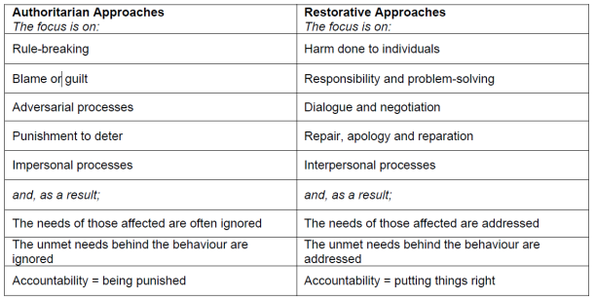

What is a restorative response to harm or conflict?
Those affected are invited to share:
1. What has happened
2. What the impact has been on those involved i.e. who has been affected and in what ways they have been affected
3. What needs to happen to put things right or to make things better in the future.

This approach is based on how people relate to each other and how best to meet the different needs that can arise from conflict and harm.

It is important to:
• Establish a respectful rapport with people
• Listen and respond calmly, emphatically and without interruption or judgement to all sides of the issue
• Inspire a sense of safety and trust
• Encourage people to express their thoughts, feelings and needs appropriately
• Appreciate the impact of people’s thoughts, feelings, beliefs and unmet needs on their behaviours
• Encourage those involved in the problem to find their own solutions.

What is being restored?

This depends on the context and on the needs of those involved. What is being restored is often something between the people involved such as:
• Effective communication
• Relationship, and even friendship
• Empathy and understanding for the other’s perspective;
• Respect
• Understanding the impact of one’s own behaviour on others
• Reparation for material loss or damage. Something may also be restored within an individual such as
• A sense of security
• Self-confidence
• Self-respect
• Dignity.

Overall, the process often results in the restoration of someone’s sense of belonging to a community e.g. class, school, peer group or family.

What are the key elements of Restorative approaches?

Restorative approaches are value-based and needs-led. They are part of a broader ethos or culture that identifies strong, mutually respectful relationships and a cohesive community as the foundations on which good teaching and learning can flourish. In this type of community, children are given responsibility for decision making in issues that affect their lives, learning and their experience of school.

Restorative approaches build upon:
• Genuineness – honesty, openness, sincerity
• Positive regard for all individuals – valuing the person for who they are
• Emphatic understanding – being able to understand another’s experience
• Individual responsibility and shared accountability
• Self-actualisation – the human capacity for human growth
• Optimistic perspectives on personal development – that people can learn and can change for the better.

These values not only underpin the more formal restorative approaches but they can also be practised in informal day to day interaction with others. This is a helpful way to ‘model’ effective ways of building and maintaining emotionally healthy relationships and promoting positive social attitudes, that may not be readily available in other areas of a young person’s life.

Why are Restorative Approaches helpful?

Staff, children and parents/carers who work restoratively report that this way of working leads to:
• A more respectful climate
• A shift away from sanction-based responses that aim to ‘manage’ behaviour, toward a more relational approach
• Better relationships amongst children and staff
• People being more honest and willing to accept responsibility
• People feeling more supported when things go wrong
• A calmer, quieter and more productive learning environment.

The Thrive Approach

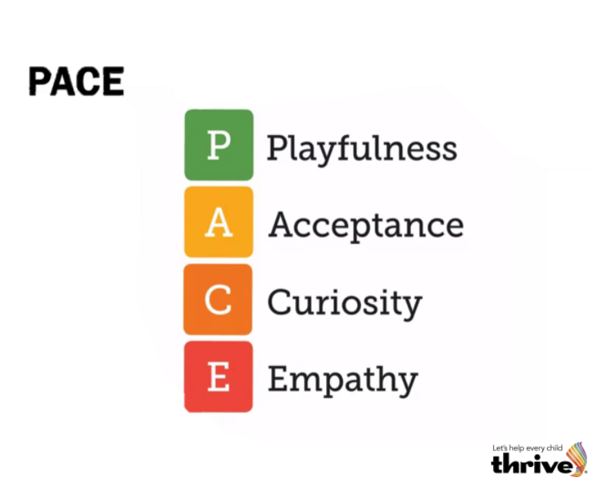

PACE is the acronym used by psychologist Dan Hughes to describe the optimal adult stance when working with children to reduce stress, enhance connection, promote safety and engender the learning of new social and emotional skills. • Playfulness: sensitive and appropriate playfulness helps the child feel safe and promotes positivity • Acceptance: unconditionally accepting the child makes them feel safe, secure and loved • Curiosity: genuine and non-judgemental interest in the child helps them become aware of their inner life • Empathy: demonstrating compassion for the child and their feelings supports the child’s sense of self-worth.
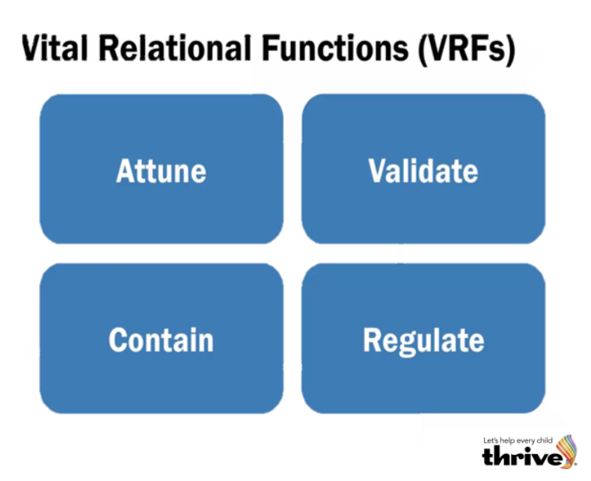
The VRFs represent the key techniques that we consciously apply in relationship.
• Attunement: matching the energy of the child with non-verbal, prosodic, energetic and behavioural
communication
• Validation: acknowledging the validity of the feelings the child is experiencing
• Containment: predictability, routine and experiencing safety and security both relationally and environmentally
• Regulation: transforms what was too much to bear alone into an experience that can be tolerated together.

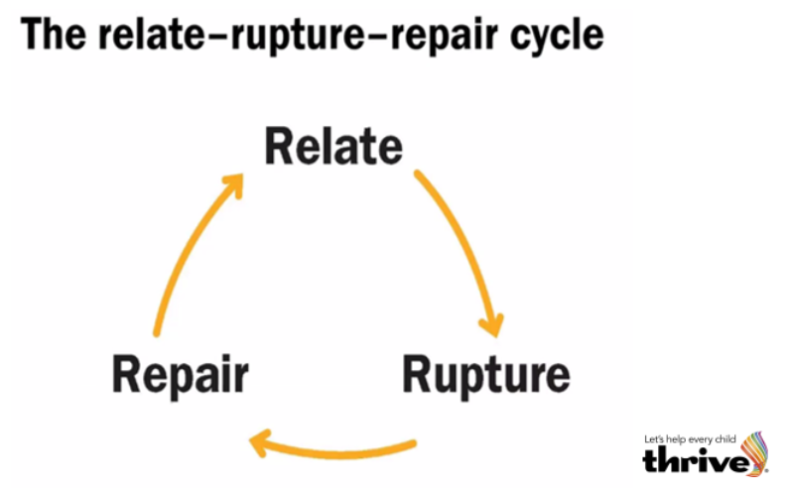
Inevitably there will be times when there is a break in the nurturing connection between the adult and child. For example, if the adult is tired, busy dealing with something else or is emotionally unavailable due to a major life event, and so on. While we might do our best to minimise these breaks in connection, when they do happen, they can be repaired, and learning can come from this experience. Research scientist Suzanne Zeedyk shares with us that “making up is more important than messing up.” Dr Zeedyk refers to the everyday scenarios where relationships between two people go through a rhythm of relating (in relationship), a rupture happening in the relationship and then making a necessary repair to the rupture in order to return to relationship. The repair not only rewires patterns of behaviour; it also establishes trust. This is known as the relate–rupture–repair cycle. When we look at each element of relate, rupture and repair, we examine the specific skills we, as adults, can use to help support these interactions with the children we work with.

