PSHE
Healthy Me
Session 1
Tuesday 23rd February 2021
WALT: take responsibility for our health and make choices that benefit my health and well-being.
Key Vocabulary
Responsibility
Choice
Immunisation
Prevention

Give yourself 2 minutes thinking time…
What are you responsible for?
How many different things can you think of?
Make a list…

As you get older, you will become responsible for more parts of your lives. This includes looking after your health and keeping yourself safe.
I wonder if you know what an Agony Aunt is?
If you aren’t sure, an Agony Aunt is a person (doesn’t have to be female!) who gives advice. Perhaps you’ve seen or heard of one on the TV, online or in a magazine.

Task: You are going to act as an Agony Aunt in today’s session. When you do this, you should include advice about the character needing to take responsibility for the ‘problem’ and also offer them suggestions to improve the situation. The scenarios are below. Choose 3 scenarios and write a reply- as the Agony Aunt. What would your advice be?

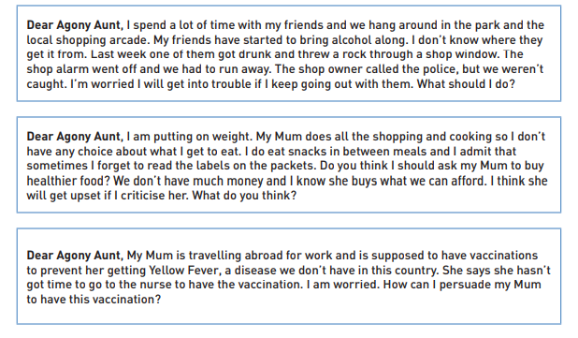
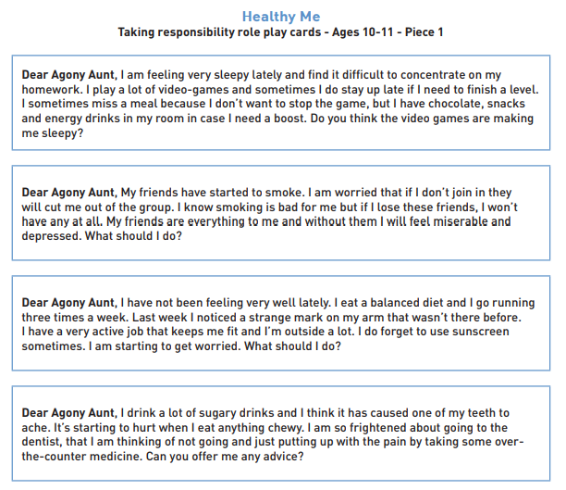
Questions to consider at the end of today’s session:
How can these people take more responsibility for managing their health?
What have you learned about taking more responsibility for your health?
Are there things you could be doing now to improve this?

