F
S O

WALT: I       F

L 
Fr Lesson1 Stage2 Spring 2 HSKT - YouTube

P   
W               
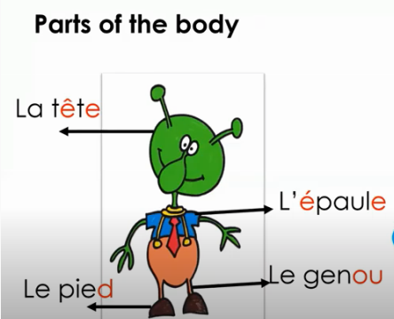

T
