Scargill Church of England Primary School

Beech Lane

West Hallam

ILKESTON

DE7 6GU

Head of School Mrs S Hallsworth

Executive Head Mr M Hetherington

Tel 0115 932 0005

Email: [info@scargill.derbyshire.sch.uk](mailto:info@scargill.derbyshire.sch.uk)

Website: www.scargill.derbyshire.sch.uk

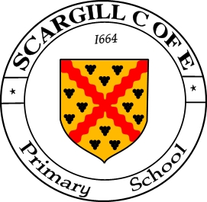

4th October 2022

**Parents’ Evenings – October 2022**

Dear Parents/Carers,

We are delighted that our children are settling back into school so well. We are inviting parents into school for parents evening this term. This will give you an opportunity to look at your child’s work as well as talk to their teacher. This meeting is for parents and there is no creche facility available. Any younger children accompanying their parents need to remain with them at all times. For parents of children with SEND, please note SSPs will be shared with you as part of the meeting.

To assist with arranging the meetings, we are using a system where parents can book their appointment online. There are two evenings for parents to choose from for their appointment:

**Monday 17th October 3.40pm – 6.15pm**

**Thursday 20th October 3.40pm – 6.15pm**

A link will be sent to your mobile phone which will take you to our online booking system to select a time convenient for you. Please follow these simple steps to book your slot:

1. Click the link that you receive through text to take you to the confirmation page. You will need internet access to do this.
2. Enter your child’s first name to continue. If you have more than one child, any of their first names will work.
3. Next you will be taken to the booking page. This will show your children alongside all of the teachers that you can book in with.
4. Click ‘Please Choose’ to be shown a list of available times that you can click to book. This will even give you the option to add any notes that you might want the teacher to see before the meeting.
5. After you have entered any notes, please click ‘Book this Slot’ to complete your booking. When the button has turned green you know your booking has been made.

6. At any time before the Parents Evening, you can click the link on your phone again to check your booking time or even un-book by clicking the green booked button.

Please make sure you book your parents evening as soon as possible to ensure you get the best time for you. Appointments must be booked by **midday on** **Friday 14th October**.

Yours sincerely,

Mrs Hallsworth

Head of School